Meta Ad Performance Queries
KPI’s
- Total Impressions Count

Select count(event_type) as Impression
from ad_events
where event_type = 'Impression'

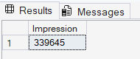

- Total Clicks Count

Select count(event_type) as Clicks
from ad_events
where event_type = 'Click'

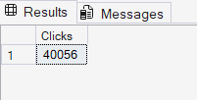

- Total Shares Count

Select count(event_type) as Shares
from ad_events
where event_type = 'Share'

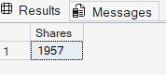

- Total Comment Count

Select count(event_type) as Comments
from ad_events
where event_type = 'Comment'

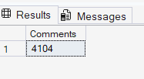

- Total Like Count
Select count(event_type) as Likes
from ad_events
where event_type = 'Like'

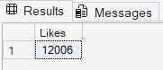
- Total Purchases Count

Select count(event_type) as Purchase
from ad_events
where event_type = 'Purchase'

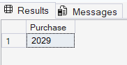

- Total Engagements Count

Select count(event_type) as Engagements
from ad_events
where event_type in ('Click','Share','Comment')

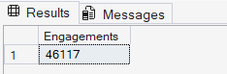

- Total CTR Count

Select cast(
cast((SELECT COUNT(*) FROM ad_events WHERE event_type = 'Click') as decimal(10,2))*100/
cast((SELECT COUNT(*) FROM ad_events WHERE event_type = 'Impression') as decimal(10,2)) as decimal(10,2)) as ClickThroughRate

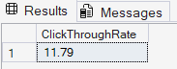

- Total Engagement Rate Count

Select cast(
cast((SELECT COUNT(*) FROM ad_events WHERE event_type in ('Click','Share','Comment')) as decimal(10,2))*100/
cast((SELECT COUNT(*) FROM ad_events WHERE event_type = 'Impression') as decimal(10,2)) as decimal(10,2)) as Engagement_Rate

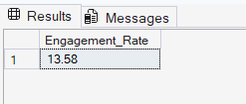

- Total Conversion Rate Count

Select cast(
cast((SELECT COUNT(*) FROM ad_events WHERE event_type = 'Purchase') as decimal(10,2))*100/
cast((SELECT COUNT(*) FROM ad_events WHERE event_type = 'Click') as decimal(10,2)) as decimal(10,2)) as Conversion_Rate
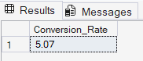
- Total Purchase Rate Count

Select Cast(
Cast((select Count(*) From ad_events where event_type = 'Purchase') as decimal(10,2))*100/
Cast((Select count(*) from ad_events where event_type = 'Impression') as Decimal(10,2)) as decimal(10,2)) as Purchase_Rate
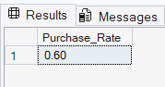
- Total Budget
Select Cast(
Sum(total_Budget)/1000000 as decimal(10,2)) as Total_Budget
From campaigns
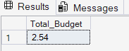
- Average Budget

Select Cast(
Avg(total_Budget)/1000 as decimal(10,2)) as Average_Budget
From campaigns

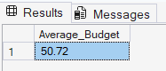

Charts and Visualizations

- Target Gender – Donut Chart

Select a.target_gender, count(a.ad_id) as 'Count'
From ads a join ad_events ae on a.ad_id = ae.ad_id
where ae.event_type = 'Impression' and a.ad_platform = 'Facebook'
Group by a.target_gender

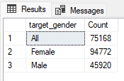

- Target Age Group – Bar Chart
Select u.user_age, count(ae.user_id) as 'Count'
From
users u join ad_events ae on u.user_id = ae.user_id
join ads a on a.ad_id = ae.ad_id
where ae.event_type = 'Impression' and a.ad_platform = 'Facebook'
Group by u.user_age
order by u.user_age

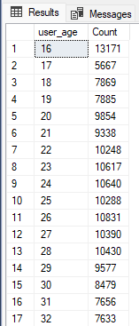

- Country – Map

Select u.country, count(ae.user_id) as 'Count'
From
users u join ad_events ae on u.user_id = ae.user_id
join ads a on a.ad_id = ae.ad_id
where ae.event_type = 'Impression' and a.ad_platform = 'Facebook'
Group by u.country
order by u.country

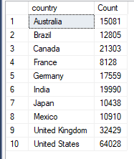

- Calendar Month – Calendar Heat Map

Select cast(ae.timestamp as date) as Date, count(ae.user_id) as 'Count'
From
ad_events ae
join ads a on a.ad_id = ae.ad_id
where ae.event_type = 'Impression' and a.ad_platform = 'Facebook'
Group by cast(ae.timestamp as date)
order by cast(ae.timestamp as date)

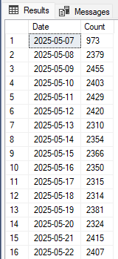

- Weekly Trend – Stacked Column by Ad Type

Select DATEPART(ISO_WEEK, CAST(ae.timestamp AS DATE)) AS WeekNumber, count(ae.user_id) as 'Count'
From
ad_events ae
join ads a on a.ad_id = ae.ad_id
where ae.event_type = 'Impression' and a.ad_platform = 'Facebook' and a.ad_type = 'Video'
Group by DATEPART(ISO_WEEK, CAST(ae.timestamp AS DATE))
order by DATEPART(ISO_WEEK, CAST(ae.timestamp AS DATE))

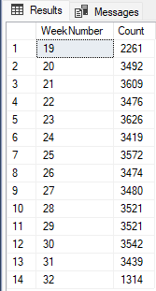

- Hourly Trend – Area Chart

Select DATENAME(hh, ae.timestamp) AS Hours, count(ae.user_id) as 'Count'
From ad_events ae
join ads a on a.ad_id = ae.ad_id
where ae.event_type = 'Impression' and a.ad_platform = 'Facebook’
--and DATENAME(hh, ae.timestamp) >=22 and DATENAME(hh, ae.timestamp) <23
Group by DATENAME(hh, ae.timestamp)
order by DATENAME(hh, ae.timestamp) asc

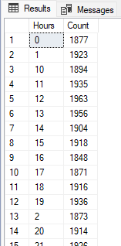
- Ad Type – Matrix

SELECT
a.ad_type,

-- Impressions
COUNT(CASE WHEN ae.event_type = 'Impression' THEN 1 END) AS IMPR,

-- Clicks
COUNT(CASE WHEN ae.event_type = 'Click' THEN 1 END) AS CLKS,

-- CTR = Clicks / Impressions
CAST(
COUNT(CASE WHEN ae.event_type = 'Click' THEN 1 END) * 100.0 /
NULLIF(COUNT(CASE WHEN ae.event_type = 'Impression' THEN 1 END), 0)
AS DECIMAL(10,2)) AS CTR,

-- Engagement Rate (Share + Click + Comment) / Impressions
CAST(
COUNT(CASE WHEN ae.event_type IN ('Share','Click','Comment') THEN 1 END) * 100.0 /
NULLIF(COUNT(CASE WHEN ae.event_type = 'Impression' THEN 1 END), 0)
AS DECIMAL(10,2)) AS ER,

-- Conversion Rate Purchase / Click
CAST(
COUNT(CASE WHEN ae.event_type = 'Purchase' THEN 1 END) * 100.0 /
NULLIF(COUNT(CASE WHEN ae.event_type = 'Click' THEN 1 END), 0)
AS DECIMAL(10,2)) AS CR

FROM ad_events ae
JOIN ads a
ON a.ad_id = ae.ad_id
WHERE a.ad_platform = 'Facebook'
GROUP BY a.ad_type
ORDER BY a.ad_type;

